9/21/24 - Ranchers Release the Hounds Invite – Gray, GA

Bus will leave EC at 5:00am, so please arrive at 4:45am to pack up.

*Important – buy tickets prior to the meet, internet will be limited in Gray.

Purchase tickets click the following: ($8 spectator fee) **NO CASH ACCEPTED**.

GoFan link: <https://tinyurl.com/mrypnuwe>

High School 5K Course

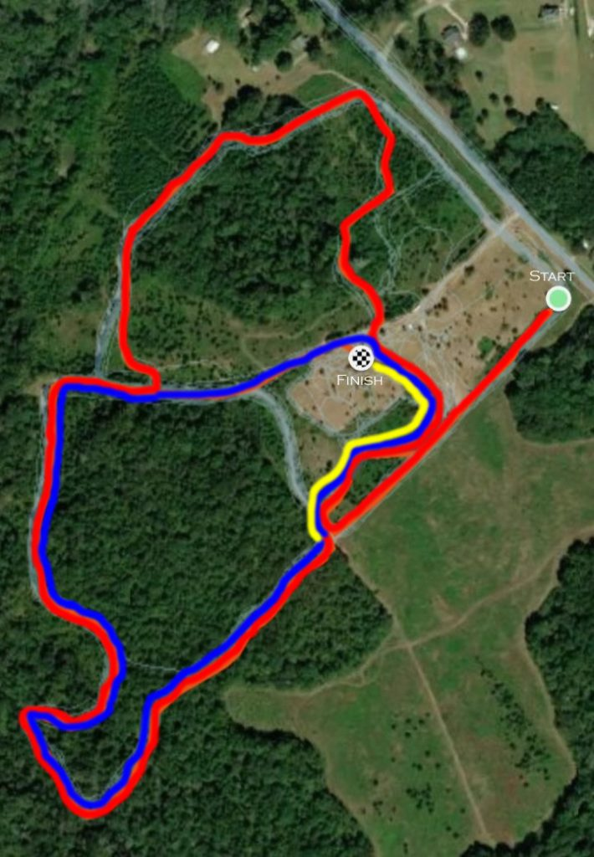  
  
**MEET INFO**  
  
Course address: 297 Howard Roberts Rd. Gray, GA 31032  
  
Spectator parking address*: **Dames Ferry Elementary School at 545 Georgia Hwy 18 West Gray, GA 31032**

**PARKING INFO**  
  
The course address is 297 Howard Roberts Road, Gray, GA near Dames Ferry Elementary School.  
  
*Team busses will park at the course.  
  
*Handicapped parking available at the course.  
  
*PARKING PARKING PARKING:* With the exception of handicapped spectators and those with passes, all car parking will be at **DAMES FERRY ELEMENTARY SCHOOL** located at *545 Georgia Hwy. 18*, which is only 1 mile away. A total of 3 buses will run every 5 minutes to transport spectators back and forth from the course.  
  
**$8.00 GO FAN payment is due for every spectator over the age of 5. NO CASH ACCEPTED.**  
  
GoFan link: <https://tinyurl.com/mrypnuwe>  
  
T-shirts, concessions, and Dairy Queen Biscuits will all be available on-site.

**RACE SCHEDULE and Entries**

* 8:00 National Anthem
* 8:15 Boys Varsity Large School Race - AAAA, AAAAA, AAAAAA (top 8 runners)

*Tucker Hancock, Parker Wilson, Kolt Nichols, Santiago Veloso, Cam Knight, Gabe Walton, Gabriel Lyannas, Owen Jenkins*

* 8:45 Girls Varsity Large School Race - AAAA, AAAAA, AAAAAA (top 8 runners)

*Daphnee’ Houde, Emily Thrailkill, Natalie Zern, Brooke Leedy, Rachel Danekes, Josie Moreau, Taryn Strother, Gerda Buka*

* 9:15 Boys Varsity Small School Race - All Private Schools and A, AA, AAA Public (top 8 runners)
* 9:45 Girls Varsity Small School Race - All Private Schools and A, AA, AAA Public (top 8 runners)
* 10:15 Boys Junior Varsity (unlimited)

Tramel Carlson, Kaiden Hall, Dylan Jackson, Will Lane, Joshua Langford, Jeremiah McMullen, Brett Meredith, Ty Peruski, Shaun Ramone, Marco Roman, Cameron Vargas, Jobson Vazquez, Zayvion Wade, Jonathan Wheeler

* 11:00 Girls Junior Varsity (unlimited)

*Alana Arnold, Ellie Chaves, Hannah Hind, Madison Mosher, Kayla Perry, Ashlee Weaver, Lillian West, Kersten Westbrook, Sania Willingham*

* 11:45 Middle School Boys
* 12:15 Middle School Girls

Medals will be awarded to the top 20 runners of each race in the finish chute.  
  
Team awards will be handed out to 1st and 2nd place teams at the end of each set of races.