**Mary Persons Bulldog Distance Classic 2024**

The bus will leave at 5am, so be at EC to help pack up at 4:45am.

**Location -**

The meet will be held at the Monroe County Recreation Center in Forsyth, GA.

100 Dan Pitts Drive, Forsyth, GA 31029. The course is located less than a mile off interstate 75 exit 188.

The meet will be chip timed by Hardy Race Timing Company.

**Entry Fee -**

$10 parking fee per car. Parking can be purchased ahead of time using GoFan: <https://gofan.co/event/1643797?schoolId=GA19146>

**This is a "no cash" event. Card payments only.**

*\*\*We will have concessions including Chick-fil-A chicken biscuits available for runners and spectators.* ***No cash. Card only.****\*\**

**Race Schedule:**

7:30 am Varsity Boys (top 10 runners, must finish under 26:00)

Tucker Hancock, Allen Goodman, Kolt Nichols, Parker Wilson, Judah Dukes, Gabe Walton, Cameron Knight, Santi Velloso, Owen Jenkins, Evan Vigh

8:00 am Varsity Girls (top 10 runners, must finish under 30:00)

Daphnee’ Houde, Emily Thrailkill, Rachel Danekes, Natalie Zern, Josie Moreau, Taryn Strother, Brooke Leedy, Ellie Chaves, Gerda Buka, Ashlee Weaver

8:40 am JV combined (unlimited)

Alana Arnold, Landon Bordeaux, Tramel Carlson, Kaiden Hall, Hannah Hind, Dylan Jackson, Will Lane, Joshua Langford, Kara Lasiter, Jeremiah McMullen, Brett Meredith, Brandon Moore, Riley Morris, Madison Mosher, Kayla Perry, Ty Peruski, Johnny Rament, Shaun Ramone, Marco Roman, Travis Shearer, Jobson Vazquez, Zayvion Wade, Lillian West, Kersten Westbrook, Jonathan Wheeler, Sania Willingham

**Awards:**

Awards for the top 3 teams in Varsity HS races

Medals Top 10 individuals in Varsity race

HS and MS awards ceremony at the pavilion behind the gym building at the conclusion of the MS races.

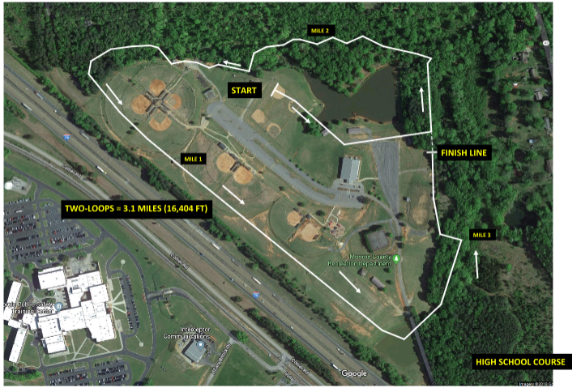Race Course –